**Experiential Learning Programme**

# Module 01 – Mushroom Cultivation

*Submitted in partial fulfillment of the requirements for the degree of*

Bachelor of Science

in

**Agriculture**

*by*

**MANISHA KASHYAP**

**AGTG021810036**

**Under the guidance of**

**M Ranjana Devi & Dr. Paritosh Kumar**

### Tilka Manjhi Agriculture College, Godda, Jharkhand.



**DECLARATION**

We hereby declare that the thesis entitled “**Mushroom Cultivation**” submitted by me, for the award of the degree of ***Bachelor of Science in Agriculture*** to TMAC, Godda is a record of bonafide work carried out by me under the supervision of **M. Ranjana Devi & Dr. Paritosh Kumar .**

We further declare that the work reported in this thesis has not been submitted and will not be submitted, either in part or in full, for the award of any other degree or diploma in this institute or any other institute or university.

Signature of the Candidate

### Manisha kashyap

**ACKNOWLEDGEMENTS**

I feel highly elated to express my profound and sincere sense of gratitude to our honourable Vice Chancellor Dr. Omkar Nath and Dean Faculty of Agriculture Dr.S K Pal who gave me the great opportunity to take part in the ELP programme.

With the same spirit I would like to express my indebtedness for coordination and guidance. I would also like to thank Dr.Ranjana Devi, Dr. Paritosh Kumar for their continuous assistance without which this Experiential Learning Programme would not have been a success. I would like to thank all the professors of all dept. who guided us in this programme.

To this, I add my deep sense of gratitude and heartily thanks to all the professors of different disciplines of agriculture faculty for their precious time for imparting us teaching & training. It is a great privilege to work under the loving & caring guidance of our instructors.

I give my special thanks to all my friends and family members who accompanied me during experiential learning programme. I would also like to thank my batch-mates, my seniors and juniors for their pretty involvement & suggestions and for their continuous cooperation.

**MANISHA KASHYAP**

**Executive Summary**

In this proposed work, I got the opportunity of gaining knowledge from experiential learning Program (ELP). The entire program was divided into two modules. In the First module General production, processing and marketing of mushroom was taught. setting up a business plan to work on it in near future. The program was organized in such a manner that we gained theoretical knowledge as well as practical knowledge.

In the first module we learnt the cogs and views of the food production and food safety. Proceeding further to it, we learnt how mushroom cultivation is done and we initiated our project work. We bought mushroom spawn from B.A.U and with the right procedure and proper guidance from our faculty members..

Moving it to a commercial scale, we started our research and prepared the business plan accordingly. With the proper calculation index and parameters, we made the costing &production of milky and button mushroom.

**TABLE OF CONTENTS**

|  |  |
| --- | --- |
| S.NO. | CONTENTS |
| 1` | Acknowledgement |
| 2 | Executive Summary |
| 3 | PREFACE |
| 4 | INTRODUCTION |
| 5 | About Mushroom Cultivation |
| 6 | About Mushrooms |
| 7 | Types of Mushrooms |
| 8 | Importance, Uses & its Side Effects |
| 9 | About Milky Mushroom |
| 10 | Health Benefits of Milky Mushroom |
| 11 | Procedure & Flowchart |
| 12 | Precautions |
| 13 | Problems |
| 14 | Marketing |
| 15 | Button mushroom introduction |
| 16 | Scientific classification |
| 17 | Procedure for production |
| 18 | Cost analysis |
| 19 | Profit and loss statement |
| 20 | Balance sheet |
| 21 | Cash flow satement |
|  |  |

# PREFACE

Experiential learning (EL) is a philosophy and methodology in which educators purposefully and focused reflection in order to increase knowledge reflection in order to increase knowledge, develop skills, entrepreneurship, and inculcate values.

The word ‘experiential’ essentially means that learning and development are achieved through personal involvement and experience, typically in group, by observation, listening, study of theory or hypothesis, rather than on received teaching or training. EL is a business curriculum related endeavour which is interactive.

The programme has end to end approach. EL thus, provides the students an excellent opportunity to develop analytical and entrepreneurial skills, and knowledge through meaningful hands-on experience, confidence in their ability to design and execute project work.

▶ *The main objectives of EL are:*

* To promote professional skills, entrepreneurship, knowledge and marketing skills through meaningful hands-on experience and working in project mode.
* To build confidence through end-to-end approach in product development.
* To acquire enterprise management capabilities including skills for project development and execution, accountancy, national/international marketing, etc.

## INTRODUCTION

* 1. **MUSHROOM CULTIVATION**

Mushroom cultivation is a technology of growing mushrooms using plant, animal and industrial waste. In short it is wealth out of waste technology. This technology has gained importance worldwide because of its dietary fibres and proteins value. Mushroom is a fungi belonging to basidiomycetes. It is rich in proteins, fibres, vitamins and minerals. There are more than 3000 types of mushrooms. e.g. Button mushroom (*Agaricus bisporus*), Oyster mushroom (*Pleurotus sps*.), Paddy straw mushroom (*Volvariella volvacea*). The cultivation takes one to three months.

Major stages of mushroom cultivation are explained below:

#### Composting

Compost is prepared by mixing paddy straw with number of organic materials like cow dung and inorganic fertilizers. It is kept at about 50oC for one week.

#### Spawning

Spawn is the mushroom seed. It is prepared by growing fungal mycelium in grains under sterile conditions. Spawn is sown on compost.

#### Casing

Compost is covered with a thin layer of soil. It gives support to the growing mushroom, provides humidity and helps regulate the temperature.

#### Pinning

Mycelium starts to form little bud, which will develop into mushroom. Those little white buds are called pins.

#### Harvesting

Mushroom grow better in 15oC - 23oC. They grow 3 cm in a week which is the normal size for harvesting. In the third week the first flush mushroom can be harvested.

## MUSHROOMS

**Mushroom**, the [conspicuous](https://www.merriam-webster.com/dictionary/conspicuous) umbrella-shaped fruiting body (sporophore) of certain fungi, typically of the order [Agaricales](https://www.britannica.com/science/Agaricales) in the phylum [Basidiomycota](https://www.britannica.com/science/Basidiomycota) but also of some other groups. Popularly, the term *mushroom* is used to identify the edible sporophores; the term [*toadstool*](https://www.britannica.com/science/toadstool)is often reserved for inedible or poisonous sporophores. In a very restricted sense, *mushroom* indicates the common edible fungus of fields and meadows (*Agaricus campestris*). A very closely related [species,](https://www.britannica.com/science/species-taxon) *A. bisporus,* is the mushroom grown commercially and seen in markets.

Umbrella-shaped sporophores are found chiefly in the agaric family ([Agaricaceae](https://www.britannica.com/science/Agaricaceae)), members of which bear thin, bladelike gills on the undersurface of the cap from which the spores are shed. The sporophore of an agaric consists of a cap (pileus) and a stalk (stipe). The sporophore emerges from an extensive underground network of threadlike strands ([mycelium](https://www.britannica.com/science/mycelium)). An example of an agaric is the [honey](https://www.britannica.com/science/honey-mushroom) [mushroom](https://www.britannica.com/science/honey-mushroom) (*Armillaria mellea*). Mushroom mycelia may live hundreds of years or die in a few months, depending on the available [food](https://www.britannica.com/topic/food) supply. As long as nourishment is available and temperature and moisture are suitable, a mycelium will produce a new crop of sporophores each year during its fruiting season.

Fruiting bodies of some mushrooms occur in arcs or rings called [fairy rings](https://www.britannica.com/science/fairy-ring). The mycelium starts from a [spore](https://www.britannica.com/science/spore-biology) falling in a favourable spot and producing strands (hyphae) that grow out in all directions.

The fungi are characterized by the absence of chlorophyll and undifferentiated bodies except the spore bearing structures**.**

## TYPES OF MUSHROOM:

#### Amantia

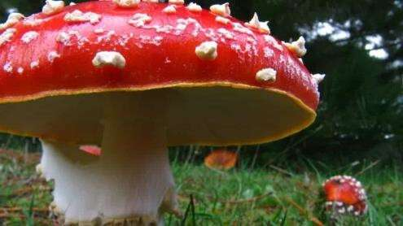

Fig 1.31 Amantia

Amanita Muscaria or fly agaric is a psychoactive fungus that attracts and kills houseflies.

* + 1. ***Beech Mushrooms***

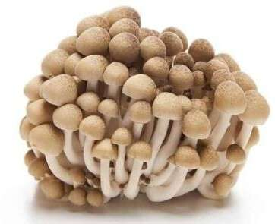

Fig 1.32 Beech Mushrooms

Also called Clamshell mushrooms, these mushrooms have caps that are brown and a crunchy, but sweet and nutty flavor.

#### Black Trumpet Mushrooms

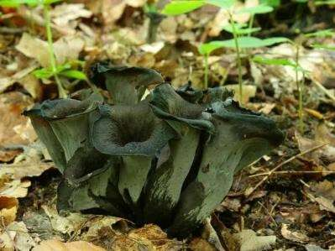

Fig 1.33 Black Trumpet Mushooms

.

Also known as the Horn of Plenty mushroom or the Trumpet of the Dead mushroom, they have a smoky, rich flavor and when dried, they are similar to the Black Truffle mushroom.

#### Button Mushrooms

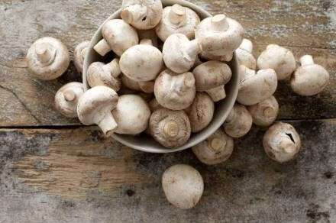

Fig 1.34 Button Mushooms

. Also called white mushrooms, they are always harvested when they’re very young, and they have a delicate, but earthy flavor.

#### Milk Mushrooms

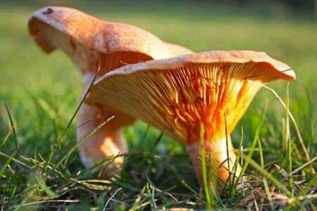

Fig 1.35 Milky Mushooms

Milk mushrooms are the only mushroom species that are native and cultivated in India. They are medium to large in size, edible, and excellent sources of vitamins B2, E, and A, phosphorus, potassium, and selenium, and also contain calcium, vitamin C, iron, and zinc.

#### Oyster Mushrooms

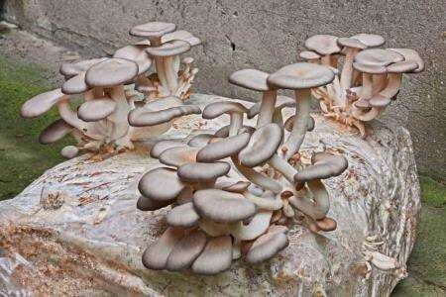

Fig 1.36 Oyster mushrooms

Oyster mushrooms look dissimilar to most other types of mushrooms, but there is no need to be intimidated by them. They have a delicate, sweet flavor and are very affordable as well. The reason they are called Oyster mushrooms is that of their appearance, and they have an almost anise-like taste at certain times of the year.

* + 1. ***Paddy Straw Mushrooms***

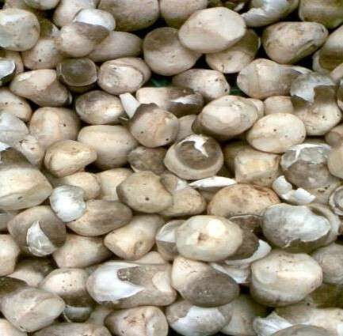

Fig 1.37 Paddy Straw Mushrooms

***Volvariella volvacea*** (also known as **paddy straw mushroom** or **straw mushroom**) is a species of [edible mushroom](https://en.wikipedia.org/wiki/Edible_mushroom) [cultivated](https://en.wikipedia.org/wiki/Fungiculture) throughout [East](https://en.wikipedia.org/wiki/East_Asia) and [Southeast Asia](https://en.wikipedia.org/wiki/Southeast_Asia) and used extensively in Asian cuisines. Worldwide, straw mushrooms are the third most consumed mushroom.

**IMPORTANCE OF MUSHROOMS**

#### [Lower Blood Pressure](https://www.webmd.com/hypertension-high-blood-pressure/how-to-lower-blood-pressure#1)

Mushrooms are rich sources of [**potassium**,](https://www.webmd.com/vitamins/ai/ingredientmono-851/potassium) a nutrient known for reducing the negative impact that sodium can have on your body.

#### [Boost Immune System](https://www.webmd.com/a-to-z-guides/features/how-use-your-immune-system-stay-healthy)

The anti-inflammatory effect of mushrooms has been shown to greatly improve the efficiency of the immune system.

#### Weight Loss

Long and short-term studies alike have found that mushrooms, in combination with exercise and other lifestyle changes, can have an important impact on weight loss.. The antioxidants in mushrooms are also thought to reduce the risk of hypertension and other metabolic disorders.

* + Mushrooms are also high in certain vitamins such as B, C, D, riboflavin, thiamine, nicotinic acid.

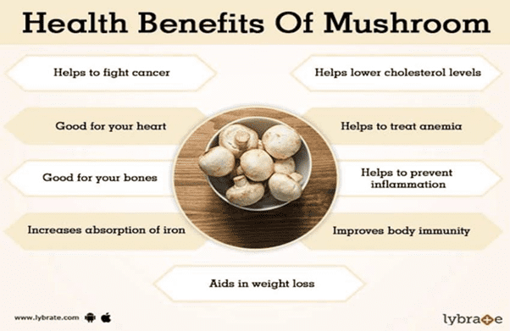

**USES OF MUSHROOMS:-**

1. **Ethanol Fuel:**

Ethanol fuel is most commonly used as an additive in gasoline, and it is usually made from grains like corn. But mushrooms may also have the power to fuel our car engines and more, too

1. **Better crops:**

Tiny little fungi grow on the roots of plants, forming symbiotic relationships with their hosts known as **mycorrhizae**. The fungi help plant roots take up the water and nutrients they need, making them vital to plant growth — and some may be better at it than others

1. **Skin Care:**

The reason why mushrooms may benefit our beauty regimen is because they contain antioxidants and vitamin D, both of which "work to protect the skin against environmental stresses, discoloration and fine lines,"

**4.Vegan Leather:**

Bolt Thread, a sustainable fashion fabric brand, uses mycelium, or mushroom tissue, to grow networks of strong fibers. The fibers weave together to create a mat of material that closely resembles a sheet of leather,

5.**Fight Cancer:**

Because mushrooms contain chemical compounds that may effect the immune system, they could point researchers to new drugs to fight cancer.

6**.Hair Loss:**

There is some evidence that the reishi mushrooms may slow or even prevent hair loss

## MILKY MUSHROOM:

***Calocybe indica***, commonly known as the **milky white mushroom**, is a [species](https://en.wikipedia.org/wiki/Species) of [edible](https://en.wikipedia.org/wiki/Edible_mushroom) [mushroom](https://en.wikipedia.org/wiki/Edible_mushroom) native to India. The sturdy all-white mushrooms appear in summer after rainfall in fields and on road verges. Traditionally eaten in West Bengal, it is being grown commercially in several Indian states and other tropical countries.

The robust mushroom is all-white in colour and has a firm consistency. Its cap is 10 to 14 centimetres across, convex initially before flattening out with age. The cuticle (skin) can be easily peeled off the cap. The mushroom does not change colour on cutting or bruising, though old dried specimens have a buff colour. The flesh has a mild flavour that has been described as oily, and a faint smell reminiscent of radishes it tastes like an unripened coconut that which we can eat it without any cooking.

*C. indica* grows in grasslands, fields and road verges in Tamil Nadu and Rajasthan, generally on substrate rich in organic material. The mushrooms appear between May and August after spells of rainfall. The fungus is [saprophytic,](https://en.wikipedia.org/wiki/Saprophytic)

*C. indica* is cultivated commercially in southern India and becoming more popular in China, Malaysia, and Singapore; it can be grown in hot humid (60% to 70%) countries with a temperature range of 25 to 35 °C year-round, It undergoes the two phases dark phase and the light phase where in dark phase the mycelium development will takes place and in the light phase the pin heads start growing. The entire process will take 45 days to get the complete milky white mushroom.

### SCIENTIFIC CLASSIFICATION

▶ Kingdom : Fungi

▶ Division : Basidiomycota

▶ Class : Agaricomycetes

▶ Order : Agaricales

▶ Family : Lyophyllaceae

▶ Genus : Calocybe

▶ Species : indica

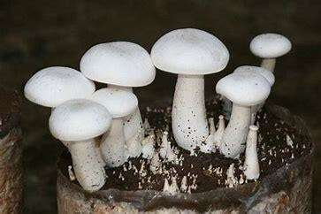

## HEALTH BENEFITS OF MILKY MUSHROOM:-

* Maintains the levels of blood sugar
* Enhance immunity system.
* Improve cardiovascular condition
* Treat skin problems.
* Maintain brain health

Activity schedule

|  |  |  |  |
| --- | --- | --- | --- |
| Phases | Courses of action | Dates | week |
| Orientation Class |  | 20-03-22 to 27-03-22 | 1st week |
| Preparatory  phase |  |  |  |
|  | 1.Site selection | 28-03-22 to 29-03-22 | 2nd week |
|  | 2. Site Cleanliness | 30-03-22 to 01-04-22 | 2nd week |
|  | 3. Rack Preparation | 02-04-22 to 05-04-22 | 2nd week to 3rd week |
|  | 4. Sterilization of room | 06-04-22 to 07-04-22 | 3rd week |
|  | 5. Raw material collection | 08-04-22 to 15-04-22 | 3rd week to 4th week |
|  | 6. Straw sterilization | 16-04-22 to 18-04-22 | 4th week to 5th week |
|  | 7.Drying | 19-04-22 | 5th week |
|  | 8. Bagging | 20-04-22 to 24-04-22 | 5th week |
|  | 9. Moisture Maintenance | 24-04-22 to till continued | Since 5th week till continued |
| Incubation phase |  |  |  |
|  | 1.Collection of raw material for casing | 12-05-22 to 14-05-22 | 8th week |
|  | 2. Soil sterilization | 15-05-22 to 18-05-22 | 4th week to 5th week |
|  | 3. Casing | 19-05-22 to 20-05-22 | 9th week |
|  | 4. Pin head starts | 31-05-22 to till continued | Since 11th week till continued |
| Production phase |  |  |  |
|  | 1.Mushroom ready to harvest | 01-06-22 | 11th week |
|  | 2. Oyster Mushroom production | 20-05-22 to 02-06-22 | 9th week |

**Materials Required**

1. wheat straw 7. Formalin
2. Spawn 8. Dyatham M45
3. Black/ red soil 9. Bleaching Powder
4. Polyethylene bags 10. Jute Bags
5. Drums 11. Sprayer
6. Tarpaulin cover 12. Cotton
7. Vermicompost 13. Rubber band

**PROCEDURE & FLOWCHART:**

1. **Site selection**

First of all we Selected 2 dark rooms for the production of mushroom. And sterilized the site with formalin solution to make the site microbes free.

1. **Rack Preparation**



Then, we went for rack preparation along

with labours in 2-3 days where mushroom

was going to be produced.And further we

sterlised it too

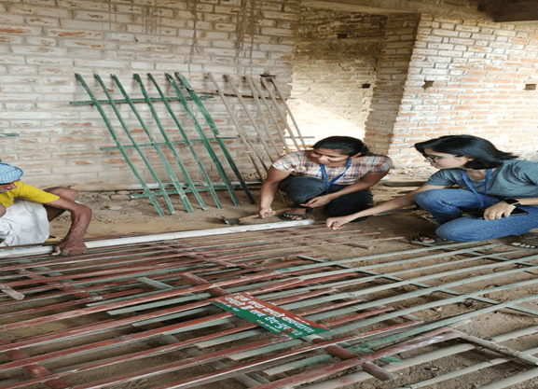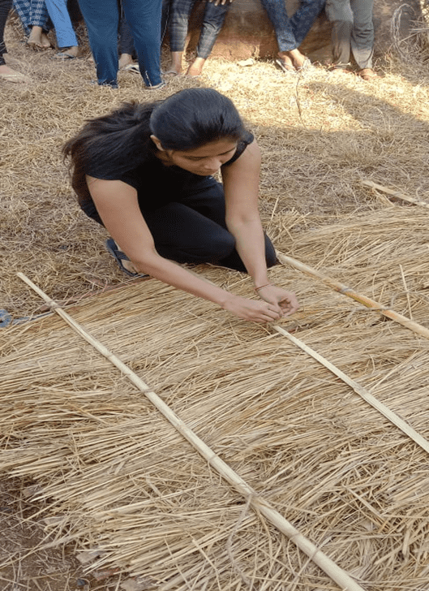

1. **Sterilization and drying of wheat straw-**

* Wheat straw are chopped into small pieces by using chaff cutter of 1 to 2 inch in length.
* Then we took a drum filled with water nearly half the amount.in which bags which are filled with paddy straw are submerged.
* Then it is chemically treated with(Dyatham M45 7.5g and Formalin 125ml) are mixed with 100l of water.
* Covered the drum and left it for 15-18 hrs.
* , After 22 hrs the excess water is drained out and straws are dried under the sun until it gets the moisture content upto 20%

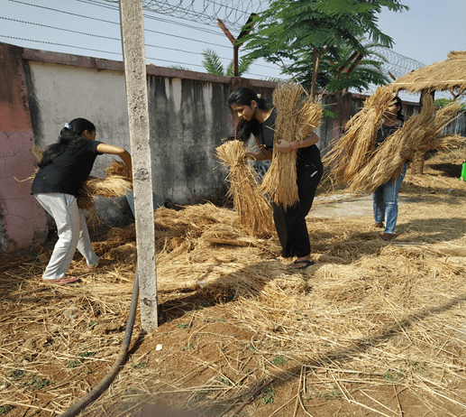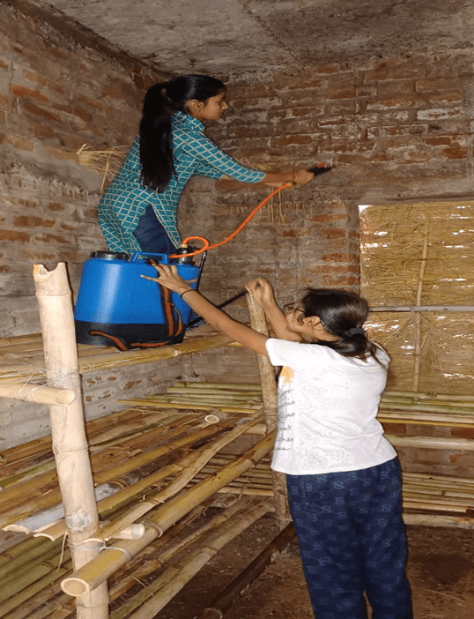

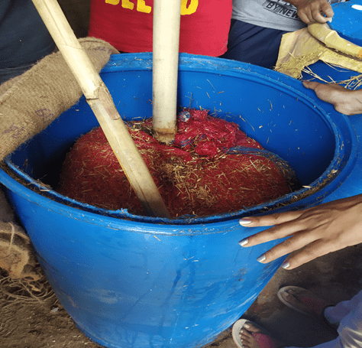 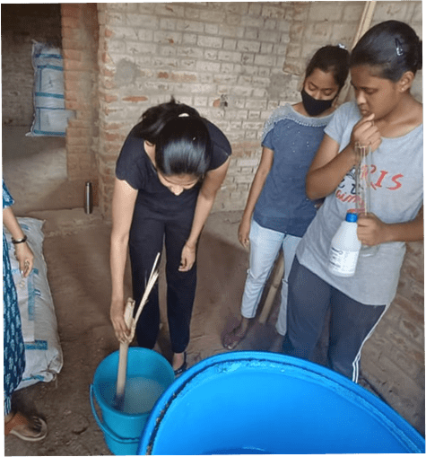

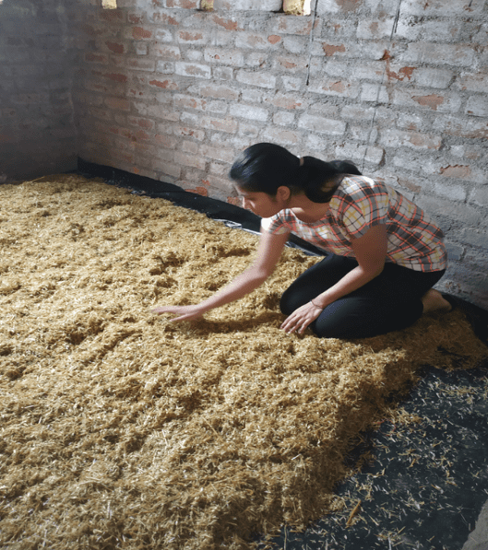 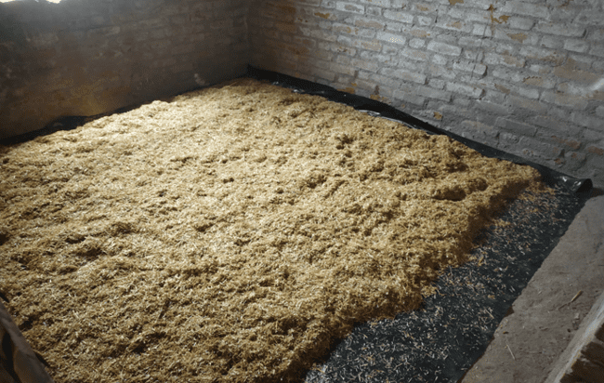

1. **Bagging**

* For bagging we took pp bags and filled it with straw and spawn layer by layer.( For 1 bag 3-4 kg straw and 200g spawn were used.)
* 1 layer of paddy straw followed by layer of spawn until it reacged to 4 layers of straw and 3 layers spawn.
* Then, bags are tied tightly,leaving no space and are kept on rack.

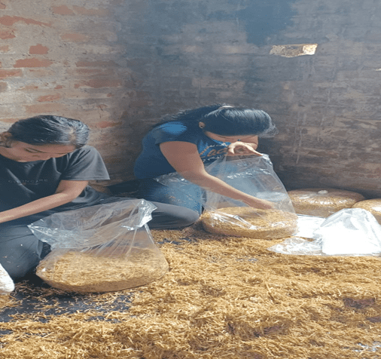 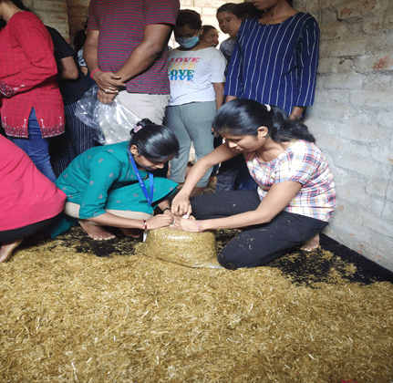

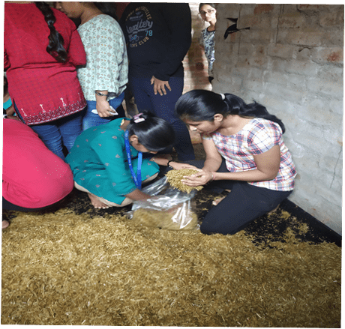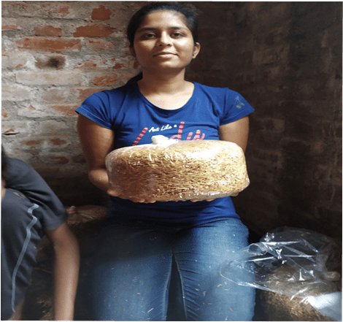

1. **Moisture maintenance**



* Maintain the temperature of 22-25° C

and relative humidity of 85-90 %

inside the shed.

* Periodically sprinkled water
* Never spray any insecticides on

the mushroom bags directly.

**6.Casing**

* Casing means covering the top surface of fully colonised bags, with pasteurized casing material.
* After complete spawn run, the bags are cut open from the top andare cased. The pond soil and sand, or coir pith, FYM and other materials can be used for casing.
* Casing thickness is 3-4 cm.



* The pH of casing material is adjusted to

7.8-7.9 with chalk powder.

* Temperature of 30-35°C and RH 80-90%

are maintained thereafter for entire

cropping cycle.

* When long bags are used, these are cut

into two at the time of casing.

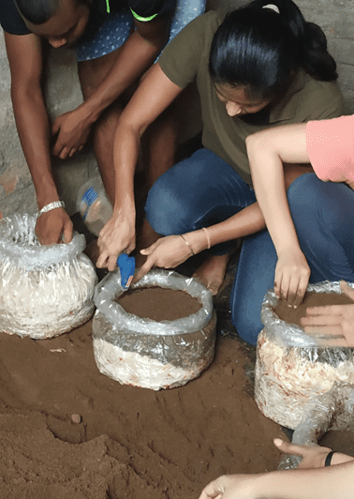 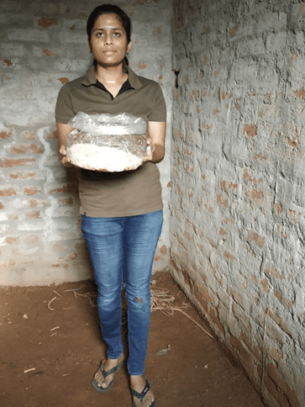

**7.Production and harvesting**

* It takes about 10 days for mycelium to reach to top of the casing layer, thereafter fresh air is introduced and minimum 3-4 air changes per hour are required
* The mushrooms appear on the top of bag just like that in button mushroom within two weeks.
* Mushrooms are harvested by twisting, cleaned and packed in
* perforated polythene/ polypropylene bags for marketing.
* The mushrooms keep on growing but it is advised to harvest these when these are about 10 cm long .
* The bigger mushrooms become fibrous**.**

## 

## 

## 

## 

## FLOWCHART

Preparation of rack

MARKETING

Production and Harvesting

Moisture maintenance in well ventilated room

Soil sterilization and Casing

Maintenance of moisture

Bagging alternating with straw and spawn

Drying for drainage of excess water

Soaking of straw in chemically treated water

Chopping of straw into small pieces

Sterlisation of room and rack

**MUSHROOM BAGS AND COST**

* Bags for practice(M0): 24
* Per group bags:
  + Group 01(M1)=30 Bags
  + Group 02(M2)= 30 Bags
  + Group 03(M3)= 30 Bags
* Disease and Contaminated bags: 27
* Monitor lizard attacked bags: 50
* Oyester bags: 12
* Milky mushroom bags:75
* **TOTAL BAG FOR CULTIVATION**= **87 BAGS**
* **COST OF 1 KG OYESTER MUSHROOM- Rs 180**
* **COST OF 1 KG MILKY MUSHROOM – Rs 140**

**COSTING AND PRODUCTION OF MILKY MUSHROOM**

|  |  |  |  |  |
| --- | --- | --- | --- | --- |
| **S. NO.** | **MATERIAL** | **QUANTITY** | **PRICE(Rs)** | **SOURCE** |
| **1.** | **STRAW** | **250 Kg @Rs 8/kg** | **2000** | **Rampur** |
| **2.** | **SPAWN** | **25+5 kg @Rs 120 /kg** | **3000** | **Agrobiotech lab Ranchi** |
| **3.** | **P.P BAG + COTTON** | **3 kg @Rs 300 /kg** | **900+60** | **Godda market** |
| **4.** | **BAMBOO** | **25-30 piece**  **@Rs 150-200/2 piece** | **3000** | **Godda** |
| **5.** | **LABOUR**  **(2 LABOUR FOR 3 DAYS )** | **@ Rs 550/day** | **1650** | **Godda** |
| **6.** | **CHEMICALS (INDOFIL M-45, FORMALIN)** | **100 g @Rs 175**  **1 bottle @ 100** | **175**  **600** | **Godda** |
| **7.** | **VERMICOMPOST** | **60 Kg (Rs 20/kg)** | **1200** | **Godda** |
| **8.** | **MISCELLANEOUS** |  | **500** | **Godda** |
| **9.** | **DRUM** | **Rs 1200/drum(2 pc)** | **2400** | **Godda** |
|  | **TOTAL COST** |  | **15685** |  |

HARVESTING OF MILKY MUSHROOM

YIELD\GROUP. GROUP1(M1) GROUP2(M2) GROUP3(M3) TOTAL

1st yield 3.635kg 2.726kg 1.635kg 7.997kg

2nd Yield 3.180kg 2.373kg 1.424kg 6.997kg

3rd Yield 3.261kg 2.446kg 1.469kg 7.176kg

GRAND TOTAL= 22.170kg

AVERAGE YIELD= 295.6g / per bag

Sale of Milky Mushroom @Rs 140/kg= Rs3103.8

HARVESTING OF OYESTER MUSHROOM

YIELD/GROUP GROUP1(M1) GROUP2(M2) GROUP3(M3) TOTAL

1st Yield 0.431kg 0.379kg 0.680kg 1.490kg

2nd Yield 0.379kg 0.284kg 0.170kg 0.510kg

3rd Yield 0.194kg 0.170kg 0.306kg 0.670kg

TOTAL 1.490kg 1.117kg 0.670kg 3.280kg

Grand total= 3.28kg

Average yield= 3.28/12 =273.3gm/bag

Sale of Oyster Mushroom @Rs 180/kg= Rs 590.4

Total sale of milky + oyster mushroom= Rs3694.2

**INSECTS,PESTS AND DISEASES**

**Insect pests:**

Many insect pests attack the mushrooms that belong to the Order Diptera. These included the Phorid fly and the Sciarid fly; Mites are also a common problem. Rats are also a problem as they eat the mushroom bags along with the spawn layers.

a) Flies:

i) Phorid fly: *Megaselia halterata* and *Megaselia tamilnodolensis*

ii) Sciarid fly: *Lycoriellamalli*

Damage:

The larvae feed on the mycelium and show rotting patches in the beds. Young buds are also eaten by the larvae. They also tunnel into the grown-up mushroom and cause rotting of the mushrooms. The flies spread the disease from one bed to another.

Favourable conditions: The temperature of 16-24 is highly favourable and moisture contents of 70 % and above show more incidences. It’s more severe in button mushroom cultivation when compared to oyster and milky mushrooms.

b) Beetles:

Black beetle: *Sacphiso manigrofaceatum*

Brown beetle: *Sacphiso mapictummotschulsky* –

Golden lines seen on the body of the insect.Both feed on young buds and grown-up mushrooms by scrapping the tissues. They mainly transmit the bacterial blotch disease from one bed to other.

c) Spring tails / Columbolas:

Tiny insects with stout antennae feed on the mycelium and buds. *Lepidocyrtuscyaneus* and *Isotoma* simplex.

d) Nematodes:

Nematode infestation is more severe in button mushrooms. The following two

nematodes are very commonly noticed: *Ditylenchus mycelophagus and Aphelenchoides*

e) Mites:

In addition to insect pests, two mites very severely feed on the mushroom spawn as well as on mushroom buttons. They are

i) Tarsonemid mite- *Tarsonem usmyceliophagu and T. floriculusfeed* on mycelium and transmit the diseases.

ii) Tryoglyphid mite- *Tyrophagus lintneri, andTyrophagus longior*.

**Integrated Pest Management**:

* Bed moisture content should be around 60- 65%.
* Fix insect-proof nets in the windows.
* In button mushroom, the newspaper should be treated with 0.1 % formalin.
* Fix white insect traps to attract the flies.
* Spray dichlorvos 0.5 ml/lit. in the floor and sides to kill the flies and beetles, never spray on the mushroom beds and buttons.

**Weeds, moulds and Diseases**

Viruses, moulds and bacteria may also compete with the mushroom mycelium thereby decreasing production.

1. Inky Cap:
   * + *Coprinus comatus* is a common weed on mushroom beds. It is favoured by high moisture content of the beds, more compaction of beds and poor ventilation with moreammonia inside the cropping room.
     + It produces dark blue to violet coloured buds with a long white thin stalk, with opens in a few days and disintegrates as a black mass of tissues, covering the entire bed, thus arresting the growth of spawn, development of young buds. The entire bed becomes black in colour show the rotting of the spawn

Management:

* Remove and destroy the infected beds immediately.
* Avoid chemical methods of sterilization as this process leads to more weed growth.

b) Green moulds:

Mainly *Trichoderma viride* is severe both in beds and on mushroom buds. In addition, *Penicillium and Aspergillus* spp. may also cause mouldy growth on the beds. The infection leads to the development of green colour patches in the beds, which spreads quickly and the entire bed is covered fully with green growth, which completely arrests the spawn from running. This is due to improper sterilization of straw and bed preparation with more moisture.

Management:

* Avoid using damaged and old straw for bed preparation.
* Remove and destroy the infected beds immediately.
* Avoid preparing beds with more than 70 per cent moisture.

c) Fungal diseases:

In addition to the above fungal diseases, some other diseases in the mushroom beds are

i) Dry bubble- *Verticillium malthousei and V. psalliotae*

ii) Truffle- *Pseudobalsamia microspora*

iii) Mildew/ Cobweb- *Dactylium dendroides*

Management:

* Avoid using damaged and old straw for bed preparation.
* Avoid preparing beds with more than 70 per cent moisture

d) Bacterial blotch/ bacterial pit / brown blotch:

This disease is caused by a bacterium, *Pseudomonas tolassi.* It produces pale-yellow spots on the surface of the pileus, which later turn brown. Pits are often found just below the surface. This disease also causes considerable damage in storage and transit. The incidence is more when the mushrooms are watered heavily in the early bud stage. Because of very high humidity film of water is always present on the surface of buttons leading to browning and rotting, emitting a foul smell. Possibly the Tyroglyphus mites carry the pathogen from one bed to other. In addition, the water splash from the infected bed also carries the bacterial inoculums.

Management:

* Keep the population of *Tyroglyphus* mite under control.
* Avoid pouring excess water into the beds.
* Remove the infected beds periodically to avoid further spread.
  + .

## PRECAUTIONS

* We need to fumigate the rooms before placing the beds. Fumigation includes mixing formalin with potassium permanganate and letting the fumes to occupy the entire room.
* Before entering either Dark or crop room we need to clean the hands and legs with dettol or soap water.
* Strict hygienic conditions must be maintained inside and premises of the farm.
* Never clean the dust inside the farm with broom stick.
* Always keep an eye on temperature and humidity percentages inside the room.
* Regularly check ,if any, for the contaminated beds.
* Do not entertain other people who want to visit your farm. (Remember man is the biggest pest for the mushroom growing)

## PROBLEMS:

### Mycelium fails to form

* ***Improper initiation strategy***. Solutions: consult parameter of growth. Alter moisture, temperature, light, carbon-dioxide, etc. Note: If the substrate is too moist, decrease moisture
* ***Chlorinated or contaminated water.*** Solutions: Use activated charcoal water filters to eliminate chemical contaminants or any other ways of simple or appropriate technology.
* ***Substrate in the bag is too hot when inoculation***. Solution: Make sure that the substrate bag is not too hot before inoculation
* ***Bad strain or spawn***. Solution: Obtain younger strain of known vitality and history
* ***Spawn contaminated.*** Solution: Pasteurize and inoculate again with good spawn
* ***Forgot to inoculate the bag.*** Solution: Make sure to inoculate

**Mycelium grows but fails to produce mushrooms**

* ***Substrate formula is not suitable***. Solutions: Adjust the formula; check pH, sawdust, additives, etc…
* ***Mites , mold, virus, bacteria and insects***. Solution: Check pasteurization process, inoculation, other processes and mushroom house management for hygiene.
* ***Inhibited by environmental toxins***. Solution: Remove source of toxins
* ***Bad strain or Shawn.*** Solution: Acquire news trains

**/ Mushrooms are deformed, decay an die.**

* ***Disturbed by germs or competing microorganisms***. Solutions: Adjust mushroom house to favor mushrooms and not germs and competitors.
* ***Dirty surface of substrate bags***. Solution: Clean the surface of substrate.
* ***Not enough air ventilation, too high humidity***. Solutions: Increase air circulation. Reduce humidity to the prescribed levels. Surface water must evaporate from mushrooms several times per day. Check watering if there is water in bags, pierce bags and drain water.

**MARKETING:-**

* Great demand for high value nutritious food since pandemic.
* There is a huge demand for mushrooms in Goddai district .
* Supply is not so much as the demand .
* There is a huge opportunity to grow in this segment.
* Our target customers the students, mess owner,professors, restaurants t.
* The plan is to expand in to other district in upcoming years.

### Figure 1 from Economics of mushroom (Agaricus bisporus) production in a selected Upazila of Bangladesh. | Semantic Scholar

**CONSTRAINTS IN MUSHROOM PRODUCTION**

* + Maintaining proper temperature and humidity .
  + Uneven sterilization of paddy straw may lead to contamination.
  + Pest problem.
  + Lack of good quality spawn .

**VALUE ADDED PRODUCTS**

* Mushroom jams
* Mushroom pickles
* Dehydrated mushrooms
* Mushroom in cans
* Frozen mushroom

**BUTTON MUSHROOM**

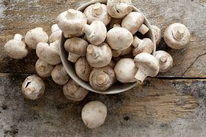

INTRODUCTION

* Button Mushroom (*Agaricus spp*.) is the most popular mushroom variety grown and consumed the world over.
* In India, its production earlier was limited to the winter season, but with technology development, these are produced almost throughout the year in small, medium and large farms, adopting different levels of technology.
* The species being grown in most farms is the white button mushroom.
* It is tiny thumbnail sized mushrooms with smooth rounded caps and short truncated stems.
* One of the most cultivated varieties in world & widely used member of Agariceae family.
* Also known as Table mushrooms.
* Depending on when they are harvested they are either stark white in colour or earthern brown like a crimini mushroom.
* Requires 20-28 C for vegetative growth and 12-18C for reproductive growth.
* Growers can take on average 3-4 crops of button mushrooms in a year depending on the type.
* The mushroom fruiting body may be umbrella like or of various other shapes, size and colour. Commonly, it consists of a cap or pileus and a stalk or stipe but others may have additional structures like a veil or annulus, a cup or volva, performing various functions in the life-cycle of the fungus.

**Scientific Classification**

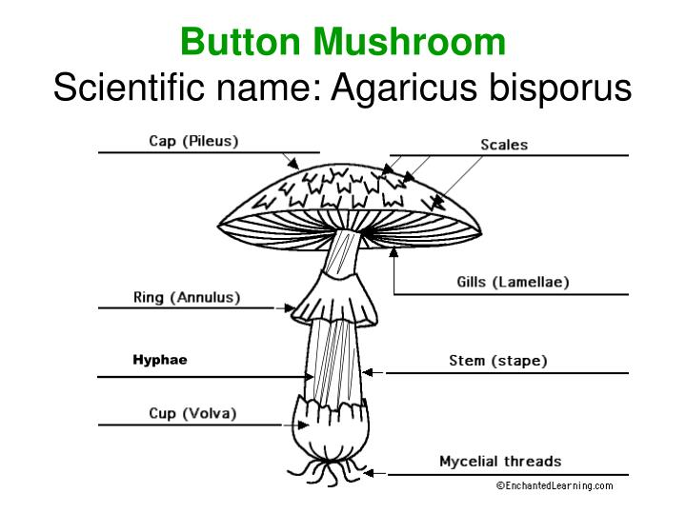

**KINGDOM**: Fungi

**PHYLUM:** Basidiomycota

**CLASS**: Agaricomycetes

**ORDER**: Agaricales

**FAMILY**: Agaricaceae

**GENUS**: Agaricus

**SPECIES:** A. bisporus

**Origin**

Cultivation of button mushrooms (*A.bisporus*) started in the sixteenth century. However, on a commercial scale, the cultivation was initiated in Europe around 17th Century. Many farms for production of button mushrooms were established and this variety still dominates the world production and consumption. India, with its diverse agroclimate conditions and abundance of agricultural wastes, has been producing mushrooms, mainly for the domestic market, for more than four decades.  Commercial production picked up in the nineties and several hi-tech export oriented farms were set up with foreign technology collaborations. But major share of mushroom production is still on small farms.

**Botanical Description**

The vegetative mycelium is composed of many inter-woven sepatate hyphae. The reproductive phase is initiated by the formation of small knob like swellings at different points of interwoven mycelial strands. These swellings increase in size and break through the surface of the substratum as small balls constituting the button stage. A matured basidiocarp (fruit body) is whitish in colour and consists of thick short stipe with an annulus. The stipe supports the pileus which appears as a hat like expansion. On the underside of the pileus, a number of radiating gills or lamella are present which are pink when young but purple-brown when mature.

**Economic Importance**

Mushrooms are highly proteinaceous and are used as food. The white button mushroom is sold as fresh mushroom or is canned and made into soups, sauces and other food products.  Protein in mushrooms have 60-70 % digestibility and contains all the essential amino acids. It has medicinal properties also. A high amount of retene is present in the button mushroom which is supposed to have an antagonistic effect on some forms of tumours.

**METHODS OF CULTIVATION**

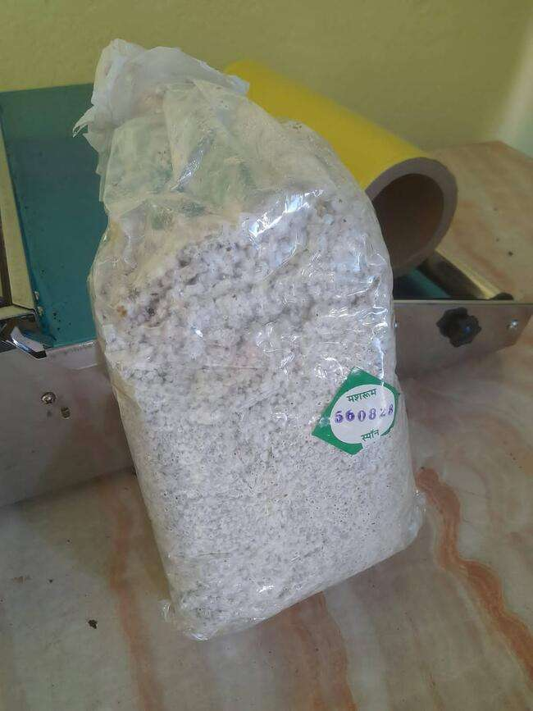

* Spawn production
* COMPOSTING
* SPAWNING AND SPAWN RUN
* CASING AND CASE RUN
* PIN HEAD FORMATION
* PRODUCTION & HARVESTING
* MARKETING

  SPAWN PRODUCTION

We can produce spawn from fruiting culture/stocks of selected strains of mushrooms under sterile conditions. However, stock culture demands laboratory operation. In that case, we can procure it from another reputed source. Moreover, you must procure good quality spawns in terms of flavor, texture, and size. Apart from these, the spawns must have the potential for high yield and longer shelf life.

**COMPOSTING**

Compost is a substrate which decomposed slowly.This helps in the growing of white mushroom. Composting will help in the degradation of microbes in organic waste. It is a process which involves decomposition of the microbes in an organic matter synthesis of the proteins in the microbes and the conditions of the materials which are fibrous.The action of the microbes changes the physical and chemical properties of the compost as well as they decrease the growth of competeitive microbes.

The quality of compost of mushroom completely depends on:-

* Nature of the material

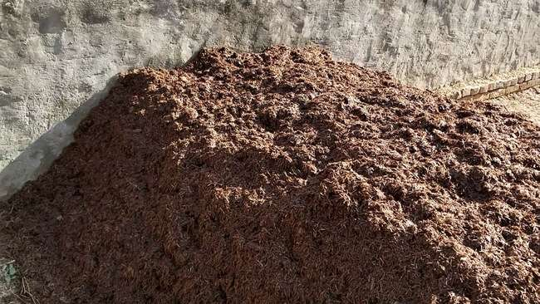

* Supplements which are both organic

and inorganic

* Managing the compost at the time

of composting

There are two methods of composting:-

**Short method of composting**

During the first phase of compost preparation, paddy straw is placed in layers and sufficient water is added to the stack along with fertilizers, wheat bran, molasses etc. The whole thing is mixed thoroughly with the straw and made into a stack (almost 5feet high,5 feet wide and of any length can be made with the help of wooden boards). The stack is turned and again watered on the second day. On the fourth day the stack is again turned for the second time by adding gypsum and watered. The third and final turning is given on the twelveth day when the colour of the compost changes into dark brown and it starts emitting a strong smell of ammonia.

The second phase is the pasteurization phase .The compost prepared as a result of microbe mediated fermentation process needs to be pasteurized in order to kill undesirable microbes and competitors and to convert ammonia into microbial protein.The whole process is carried out inside a steaming room where an air temperature of 600 C is maintained for 4 hours. The compost finally obtained should be granular in structure with 70% moisture content and pH 7.5. It should have a dark brown colour, sweet unobnoxious smell and free from ammonia, insects and nematodes. After the process is complete, the substrate is cooled down to 250 C.

**Long method of composting**

The long method of composting is usually practiced in areas where facilities for steam pasteurization is not available. In this method, the first turning is given about six days after preparation of the substrate for composting. The second turning is given on the tenth day followed by third one on the thirteenth day when gypsum is added. The fourth, fifth and sixth turnings are given on the sixteenth, nineteenth and twenty-second day. On the twenty-fifth day the seventh turning is given by adding 10% BHC (125 g.) and the eighth turning is given on the twenty-eighth day after which it is checked whether there is any smell of ammonia present in the compost. The compost is ready for spawning only if it doesn’t have any smell of ammonia; otherwise a few more turnings are given at an interval of three days till there is no smell of ammonia.

SPAWNING AND SPAWN RUN

The process of mixing spawn with compost is called spawning. The different methods followed for spawning are given below:

**(i) Spot Spawning:** Lumps of spawn are planted in 5 cm. deep holes made in the compost at a distance of 20-25 cm. The holes are later covered with compost.

**(ii) Surface Spawning:** The spawn is evenly spread in the top layer of the compost and then mixed to a depth of 3-5 cm. The top portion is covered with a thin layer of compost.

**(iii) Layer Spawning**: About 3-4 layers of spawn mixed with compost are prepared which is again covered with a thin layer of compost like in surface spawning. The spawn is mixed through the whole mass of compost at the rate of 7.5 ml./ kg. Compost or 500 to 750 g./ 100 kg. compost (0.5 to 0.75%).

After the spawning process is over, the compost is filled in polythene bags(90x90 cm., 150 gauge thick having a capacity of 20-25 kg. per bag)/ trays(mostly wooden trays 1x1/2 m. accommodating 20-30 kg. compost) / shelves which are either covered with a newspaper sheet or polythene. The fungal bodies grow out from the spawn and take about two weeks (12-14 days) to colonise. The temperature maintained in cropping room is 23 ± 20 C. Higher temperature is detrimental for growth of the spawn and any temperature below than that specified for the purpose would result in slower spawn run. The relative humidity should be around 90% and a higher than normal CO2 concentration would be beneficial.

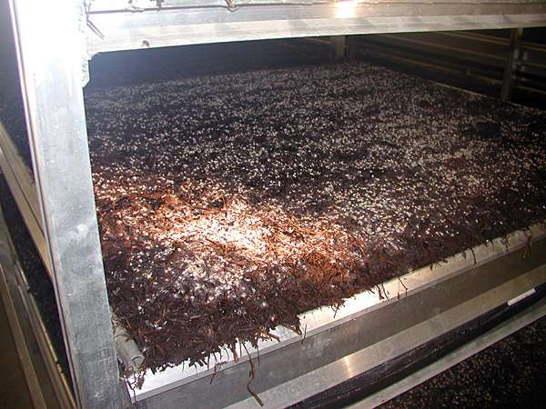

CASING AND CASE RUN

The compost beds after complete spawn run should be covered with a layer of soil (casing) about 3-4 cm. thick to induce fruiting. The casing material should be having high porosity, water holding capacity and the Ph should range between 7-7.5. Peat moss which is considered to be the best casing material is not available in India, as such the mixtures like garden loam soil and sand (4:1); decomposed cowdung and loam soil (1:1) and spent compost (2-3 years old); sand and lime are commonly used. The casing soil before application should be either pasteurized (at 66-700 C for 7-8 hours), treated with formaldehyde (2%), formaldehyde (2%) and bavistin (75 ppm.) or steam sterilized. The treatment needs to be done at least 15 days before the material is used for casing. After casing is done the temperature of the room is again maintained at 23-280 C and relative humidity of 85-90% for another 8-10 days. Low CO2 concentration is favourable for reproductive growth at this stage.

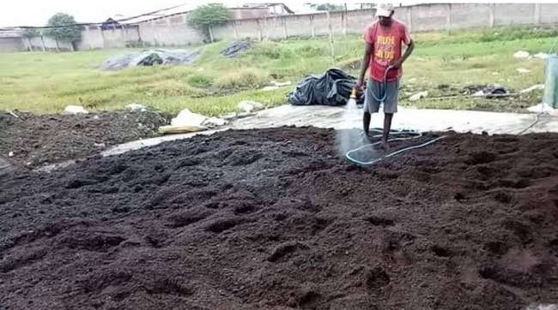

PIN HEAD FORMATION

Under favourable environmental conditions viz. temperature (initially 23 ± 20 C for about a week and then 16 ± 20 C ), moisture (2-3 light sprays per day for moistening the casing layer), humidity( above 85%), proper

ventilation and CO2 concentration (0.08-0.15 %)

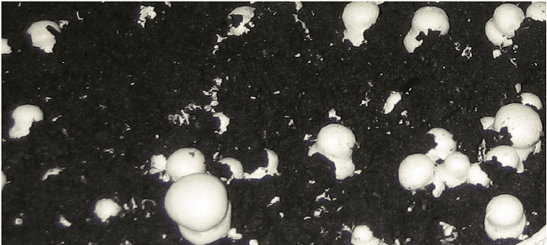

the fruit body initials which appear

in the form of pin heads start growing and gradually

develop into button stage.

PRODUCTION AND HARVESTING

Harvesting is done at button stage and caps measuring 2.5 to 4 cm. across and closed are ideal for the purpose. The first crop appears about three weeks after casing. Mushrooms need to be harvested by light twisting without disturbing the casing soil. Once the harvesting is complete, the gaps in the beds should be filled with fresh sterilized casing material and then watered. About 10-14 kg. fresh mushrooms per 100 kg. fresh compost can be obtained in two months crop.

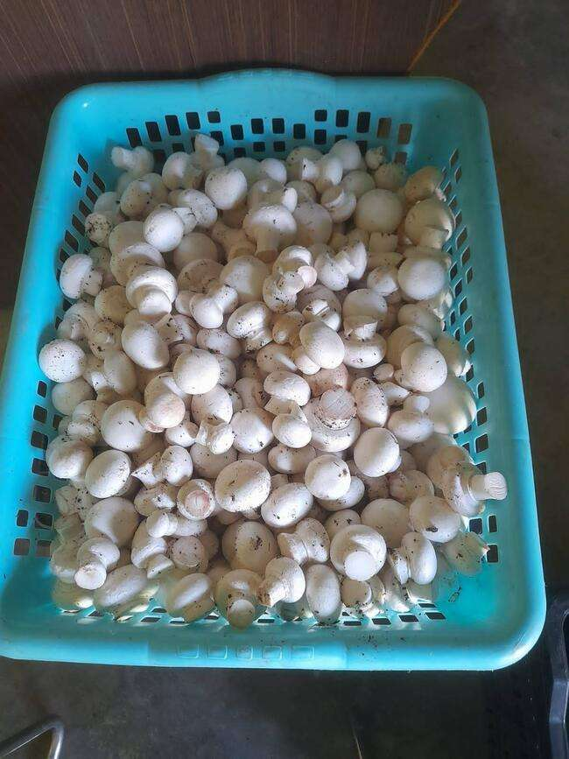 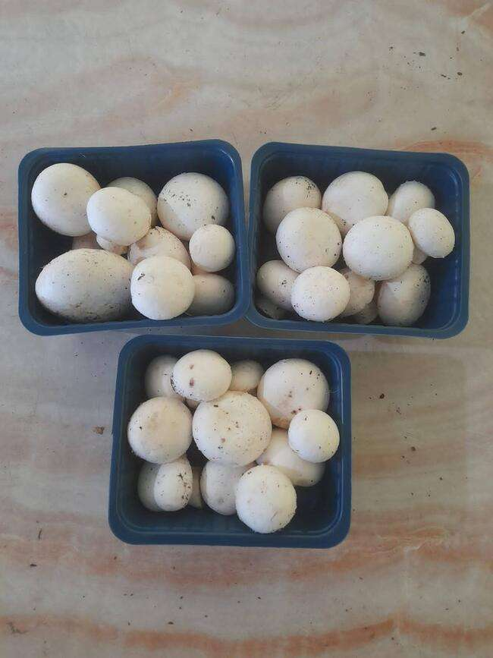

**Economics and Profitability Measures**

Cultivation under natural conditions during winter seasons requires little facilities as compared to cultivation under controlled conditions throughout the year. In general the cost of production of white button mushroom under natural conditions is Rs 50-55/kg whereas under controlled conditions, it may be around Rs 60/kg. The selling price varies from Rs 70-100 depending on season and demand. We can enhance profits through value addition. Thus, growing mushroom is a highly profitable venture. It is, however, very important to maintain hygiene and strictly follow the cultivation protocol.

**COST ANALYSIS**

* Dimension of the unit = 60 ft × 60 ft
* 1 cycle runs for 2 months so, total 6 cycles in ayear.
* In each cycle= 830 bags/round

So for 6 cycle = 830 × 6 = 5000(approx.) annually

* Space required for 6 bags = 6 sq. ft

So, for 1 bag = 6/6= 1 sq. ft

For 5000 bags= 5000 sq. ft

* Each bag gives a yield of 1 kg so, total yield =5,000 kg/annually

|  |  |  |  |  |
| --- | --- | --- | --- | --- |
| **S. no.** | **Raw materials** | **Price /unit(Rs)** | **Quantity** | **Total price(Rs)** |
| 1 | Straw | Rs 6/kg | 6 kg/bag | 1,80,000 |
| 2 | Spawn | Rs 150/kg | 350 g/bag | 1,87,500 |
| 3 | Chemicals |  |  | 9,000 |
| 4 | Polybag | For 1 cycle Rs 3500 | 6 cycle | 21,000 |
| 5 | Miscellaneous |  |  | 30,000 |
|  | **TOTAL** |  |  | **4,27,500** |

Packaging:-

For 1 kg = 5 bowl (200 gm each)

for 5000 kg = 5× 5000 = 25000 bowls

Each bowl cost Rs 2

so, 2× 25000 = Rs 50,000

|  |  |
| --- | --- |
| **Plants & Machinery** | **Price (Rs)** |
| **Straw cutter** | **30,000** |
| **Sealing machine** | **1,50,000** |
| **Refrigerator** | **30,000** |
| **Pasteurization machine** | **3,00,000** |
| **AC** | **70,000** |
| **Humidity controller** | **30,000** |
| **Weighing machine** | **10,000** |
| **TOTAL** | **6,20,000** |

**Electricity establishment** = Rs 80,000

**Electricity bill** = Rs 2500×12

= Rs 30,000

**Labour Charges**: 1 day =Rs 300

Total = 5 labour

so, 5× 300=Rs1500

For 365 days = 365× 1500

= Rs 5,47,500

**Building(rent)**= Rs 8,40,000

For, 5000 sq. ft = 70,000/month

**Water supply** = Rs 2,50,000

|  |  |  |  |  |  |  |
| --- | --- | --- | --- | --- | --- | --- |
| PROFIT AND LOSS STATEMENT | | | | | | |
|
|  |  |  |  |  | (in lakhs) | |
|  |  | **2022-23** | **2023-24** | **2024-25** | **2025-26** | **2026-27** |
|  |  |  |  |  |  |  |
| Sales |  | **20** | **22.5** | **25.2** | **26.5** | **28** |
| **COGS** |  |  |  |  |  |  |
| Raw materials |  | **4.27** | **4.8** | **5.02** | **5.2** | **5.5** |
| Packagings |  | **0.5** | **0.65** | **0.7** | **0.8** | **0.95** |
| Labour |  | **5.47** | **5.62** | **5.7** | **5.75** | **5.9** |
| Transportation |  | **3** | **3.5** | **3.7** | **4** | **4.2** |
| Electricity |  | **0.8** | **1.1** | **1.3** | **1.5** | **2** |
| TOTAL COGS |  | **14.04** | **15.67** | **16.42** | **17.25** | **18.55** |
|  |  |  |  |  |  |  |
| **Gross profit** |  | **5.96** | **6.83** | **8.78** | **9.25** | **9.45** |
|  |  |  |  |  |  |  |
| Selling expenses |  | **0.2** | **0.22** | **0.25** | **0.26** | **0.28** |
| EBIT |  | **5.76** | **6.61** | **8.53** | **8.99** | **9.17** |
|  |  |  |  |  |  |  |
| interest on term loan(8%) | | **1.44** | **0.08** | **0.08** | **0.08** | **0.08** |
| Interest on WC loan(10%) | | **0.54** | **0.56** | **0.59** | **0.61** | **0.63** |
| **PBT(profit before tax)** |  | **4.86** | **7.09** | **9.04** | **9.52** | **9.72** |
| Tax (10%) |  | **0.48** | **0.7** | **0.94** | **0.95** | **0.97** |
|  |  |  |  |  |  |  |
|  |  |  |  |  |  |  |
| **PAT (Profit after tax)** | | **4.38** | **6.39** | **8.17** | **8.57** | **8.75** |
|  |  |  |  |  |  |  |

|  |  |  |  |  |  |  |
| --- | --- | --- | --- | --- | --- | --- |
| **BALANCE SHEET** | | | | | | |
|
|  |  |  |  |  | (IN LAKHs) | |
|  |  | **2022-23** | **2023-24** | **2024-25** | **2025-26** | **2026-27** |
| **Particulars** |  |  |  |  |  |  |
| **Current assests** |  |  |  |  |  |  |
|  | Cash | **3.2** | **4.5** | **6.2** | **5.8** | **6.7** |
|  | A/R | **4** | **4.5** | **7.3** | **6.6** | **6.5** |
|  | Inventory | **3** | **5.7** | **5.3** | **6.8** | **6.4** |
| **Total Current assest** | | **10.2** | **14.7** | **18.8** | **19.2** | **19.6** |
| **Fixed assessts** |  |  |  |  |  |  |
|  | Plant & M/C | **6.2** | **0.5** | **0** | **0** | **0** |
|  | Building | **8.4** | **0** | **0** | **0** | **0** |
|  | Transportation | **7.2** | **0.5** | **0.6** | **0.65** | **0.7** |
|  | Water supply | **2.5** | **0.3** | **0.35** | **0.4** | **0.5** |
|  | Depreciation(10%) | **2.43** | **0.13** | **0.095** | **0.1** | **0.12** |
| **Total fixed assests** | | **24.3** | **1.17** | **0.85** | **0.95** | **1.08** |
| **TOTAL ASSESTS** |  | **34.5** | **15.87** | **19.65** | **20.15** | **20.68** |
| **Current liability** |  |  |  |  |  |  |
|  | Account payble | **2** | **2.5** | **2.75** | **4.2** | **4.52** |
|  | Int. on WC Loan | **0.54** | **0.56** | **0.59** | **0.61** | **0.63** |
| **Total current liability** | | **2.54** | **2.81** | **3.34** | **4.81** | **5.15** |
| working capital loan | | **5.43** | **5.68** | **5.9** | **6.1** | **6.32** |
| Term loan |  | **18** | **0** | **0** | **0** | **0** |
| Promoters capital | | **3.2** | **0.8** | **1.2** | **0.5** | **0.3** |
| PAT |  | **4.38** | **6.39** | **8.11** | **8.57** | **8.75** |
| Less drawings |  | **0.95** | **0.19** | **1.1** | **0.17** | **0.16** |
| **Total liability** |  | **34.5** | **15.87** | **19.65** | **20.15** | **20.68** |
|  |  |  |  |  |  |  |

|  |  |  |  |  |  |
| --- | --- | --- | --- | --- | --- |
| **CASH FLOW** | | | | | |
|
|  |  |  |  | (IN LAKHS) | |
|  | **2022-23** | **2023-24** | **2024-25** | **2025-26** | **2026-27** |
| **Particulars** |  |  |  |  |  |
| Opening balance | 0 | 11.88 | 22.64 | 35.21 | 48.59 |
| **INFLOWS** |  |  |  |  |  |
| Revenue | 20 | 22.5 | 25.2 | 26.5 | 28 |
| Promoters capital | 3.2 | 0.8 | 1.2 | 0.5 | 0.3 |
| Term loan | 18 | 0 | 0 | 0 | 0 |
| Cash credit | 5.43 | 5.68 | 5.9 | 6.1 | 6.32 |
| **TOTAL INFLOWS** | **46.63** | **40.86** | **54.94** | **68.31** | **83.21** |
|  |  |  |  |  |  |
| **OUTFLOWS** |  |  |  |  |  |
| Raw materials | 4.27 | 4.8 | 5.02 | 5.2 | 5.5 |
| Packaging | 0.5 | 0.65 | 0.7 | 0.8 | 0.95 |
| Building | 8.4 | 0 | 0 | 0 | 0 |
| Transport | 3 | 3.5 | 3.7 | 4 | 4.2 |
| electricity | 0.8 | 1.1 | 1.3 | 1.5 | 2 |
| Labour | 5.47 | 5.62 | 5.7 | 5.75 | 5.9 |
| Plant & machinery | 6.2 | 0.5 | 0 | 0 | 0 |
| Selling expenses | 0.2 | 0.22 | 0.25 | 0.26 | 0.28 |
| Int. on term loan | 1.44 | 0.08 | 0.08 | 0.08 | 0.08 |
| Int. on WC loan | 0.54 | 0.56 | 0.59 | 0.61 | 0.63 |
| Drawings | 0.95 | 0.19 | 1.1 | 0.17 | 0.16 |
| Tax | 0.48 | 0.7 | 0.94 | 0.95 | 0.97 |
| Water supply | 2.5 | 0.3 | 0.35 | 0.4 | 0.5 |
| **TOTAL OUTFLOWS** | **34.75** | **18.22** | **19.73** | **19.72** | **21.17** |
|  |  |  |  |  |  |
| **CLOSING BALANCE** | **11.88** | **22.64** | **35.21** | **48.59** | **62.04** |
|  |  |  |  |  |  |
|  |  |  |  |  |  |

|  |  |  |  |  |  |
| --- | --- | --- | --- | --- | --- |
| **SALE** | **FC** | **VC** | **TC** | **DB** | **DC** |
| **20** | **24.3** | **14.04** | **38.34** | **18** | **34.50** |
| **22.5** | **1.3** | **15.07** | **16.37** | **18.45** | **13.4** |
| **25.2** | **0.95** | **16.42** | **17.72** | **18.9** | **13.29** |
| **26.5** | **1.05** | **17.25** | **18.3** | **18.02** | **12.44** |
| **28** | **1.2** | **18.55** | **19.75** | **17.36** | **12.245** |
| **TOTAL** | | | | **90.73** | **85.87** |

**BENEFIT COST RATIO = DB/DC**

**= 1.05**

# THANK YOU !!!!